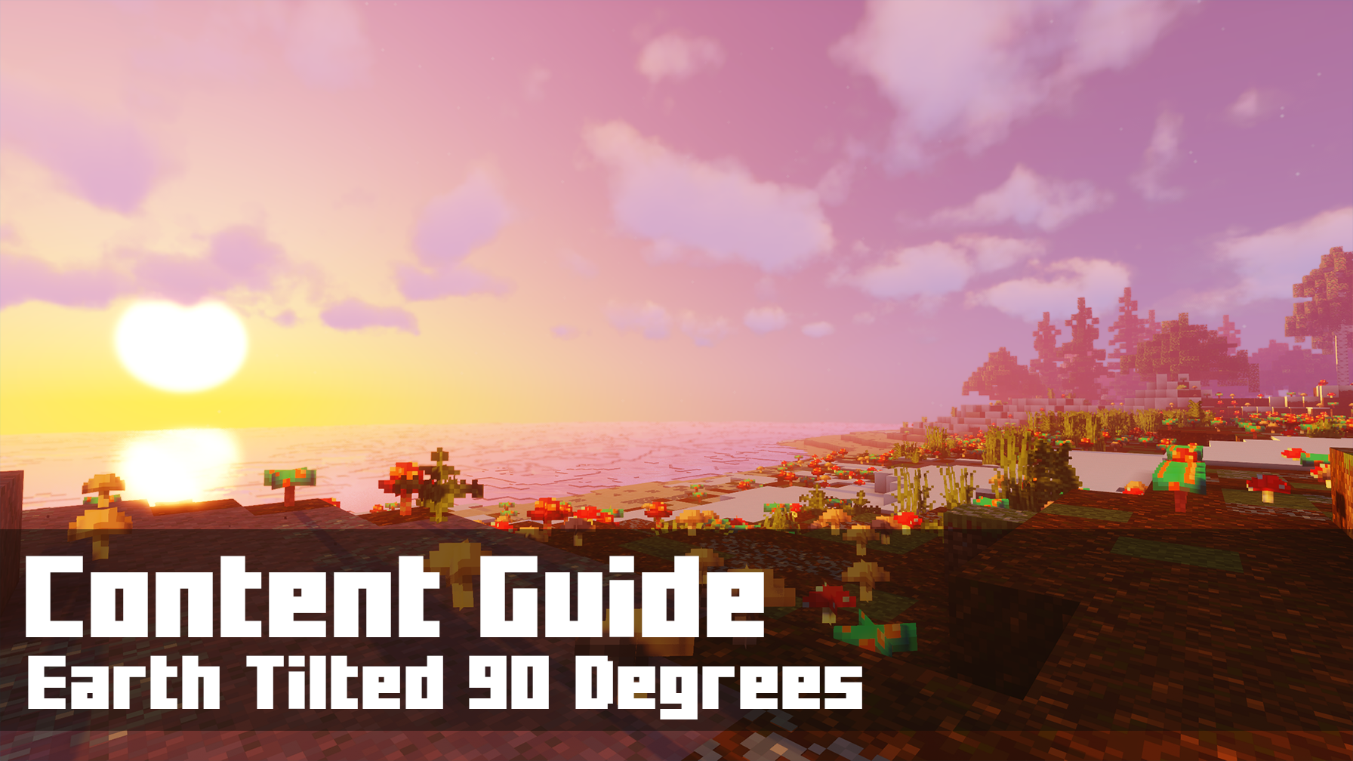
Contents  📖 Narrative Focus……………………………………………..2  🎯 Objectives……………………………………………………..2  🏫 Standards Alignment……………………………………..2  📝 Assessments………………………………………………….2  💡 Tips for Instruction………………………………………….3  🔭 Observable Concepts…………………………………….3  ❓ Expected Questions………………………………………..4  🔬 Connected Classroom Activities……………..……..4  ☑️ World Quest Progression………………………………4  🗺️ Maps……………………………………………………………..5  👩🏽‍🔬 NPC's and Their Roles………………………………….…7 | How to Use This Guide  This content guide is intended for parents, librarians, teachers, and other educators who are interested in facilitating learning experiences with the WHIMC server, in home or classroom-based settings. It reviews all the critical components of a given WHIMC world as well as what might be learned in it.  This world is the seventh players encounter, for a full overview of world order, see the teacher guide home page.  More information about project WHIMC can be found on our website at whimc.org. Teachers and participants unfamiliar with computer-based Minecraft: Java Edition can learn how to install and control the game here as well.

📖 Narrative Focus
In many ways this world is similar to our earth, but with seasonal change cranked up to the maximum. It leverages a common interest of explorers: creatures! They can see the ways life is altered for flora and fauna by time traveling between times of the year.

World Overview
Our Earth tilts 23½°, a legacy of the Theia impact that also formed the Moon. This world shows Earth's rotation axis at 90°, so the axis lies in the plane of its orbit.

Extreme Seasons & the Spiraling Sun
- Because angular momentum keeps the axis pointed in a fixed direction, the North Pole points straight at the Sun at one point in the year and straight away six months later.
- At the poles, the Sun would circle overhead 24/7 for part of the year, then spiral lower day by day until it dips below the horizon for roughly six months of continuous night.
- Seasonal temperature swings would be far more violent than anything on our Earth.

Latitude Controls Everything
- The day–night experience depends heavily on where you stand: poles see months-long day/night, while the equator sees a more rapidly shifting but still extreme cycle.
- Climate zones and habitability would be defined by latitude in ways unfamiliar to us.
- Ecosystems must survive both prolonged darkness/cold and prolonged sunlight/heat.

A Near-Normal Day, an Abnormal Year
- Despite the extreme tilt, the Moon would still have slowed Earth's rotation to a ~24-hour day
- The year remains about 365 days, but the daily and monthly motion of the Sun and Moon across the sky would look nothing like ours

🎯 Objectives
- Students will learn the importance that Earth’s tilt has in creating seasons, and how changing it affects the timing sand extremities of those seasons.
- Students will learn about the effect of the sun on melting ice, causing ocean level and tide changes.
- Students will learn how planetary conditions shape flora and fauna life cycles, and whether survival would be possible.

🏫 Standards Alignment
Next Generation Science Standards (reference)
- K-ESS2.D Weather and Climate
- 1-ESS1.A: The Universe and its Stars
- 1.ESS1.B: Earth and the Solar System
- 3-ESS2.D Weather and Climate
- 5-EES1-1: Support an argument that differences in the apparent brightness of the sun compared to other stars is due to their relative distances from Earth.
- 5-ESS1.A: The Universe and its Stars
- 5-ESS1.B: Earth and the Solar System
- MS-ESS1-1: Develop and use a model of Earth-sun-moon system to describe the cyclic patterns of lunar phases, eclipses of the sun and moon, and seasons.
- MS-ESS1-3: Analyze and interpret data to determine scale properties of objects in the solar system.
- MS-ESS1.A: The Universe and its Stars
- MS-ESS1.B: Earth and the Solar System
- MS-ESS1.C: The History of Planet Earth
- MS-ESS2.6: Develop and use a model to describe how unequal heating and rotation of the Earth cause patterns of atmospheric and oceanic circulation that determine regional climates
- MS-ESS2.D: Weather and Climate
Republic of Philippines Science Standards (reference)
- S3MT-Ia-b-1: Properties
- S3LT-IIc-d-3: Living Things- Animals
- S3ES-IVa-b-1: Earth and Space- The Surroundings
- S3ES-IVg-h-6: Earth and Space- Natural Objects in the Sky
- S4LT-IIi-j-15 & S4LT-IIi-j-16: Ecosystems
- S4ES-IVe-5, S4ES-IVf-6, S4ES-IVf-7: Weather
- S4ES-IVg-8: Weather
- S6MT-IIi-j-5 & S6MT-IIi-j-6: Ecosystems
- S7MT-Ia-1: Doing Scientific Investigation
- S8LT-IVg-19: Biodiversity

📝 Assessments
During WHIMC camps, instructors provide opportunities for students to express what they have learned in the form of short answer questions. Over time, these have taken two forms: ICAN Prompts and Self-Explanations. While teacher content guides are designed for those outside of WHIMC researcher-run camps, these prompts can be used to facilitate discussions about the server and what was learned during a playthrough of a particular world.
Self-Explanations
Tilted Earth Questions | Why might a polar bear be in the jungle on Tilted Earth? | Why is half the world in complete darkness for 3 months? | Could humans survive on Tilted Earth? Why?
Possible Answers | It's not jungle all year round, much of the year it's cold and still snowy, the scenario implies rapid yearly climate shifts and plant growth | Prompts kids to talk about the way the earth rotates (spins on its axis) always pointing in the same direction while orbiting the Sun. Tilted that far over, the Sun would be below the horizon for long periods. | In our scenario potentially, prompts kids to think about what humans need to survive. Probably would lead to mass migrations to stay warm.

Quest participation can be an indicator of engagement. This map is part of the larger series of Explore [What-If] Earths and contains Time Traveler. They are both required quests and just indicate a baseline minimum for completion, if participants complete the side quest Measuring Migrations this indicates more exploration.
On every world there are main concepts and science variables that can be observed. Instructors can expect a minimum of 3 observations of substantive quality and 3 different science measures to consider a learner to be at a level of satisfactory engagement on Earth Tilted 90 Degrees.
ICAN Prompts (retired)
ICAN tell you what Earth would be like if tilted at 90 degrees and reasons why. | ICAN come up with and describe features of my own What-If world.

💡 Tips for Instruction
- In order to undertake the quest on this map, students need to have completed quests from Earth with No Moon.
- Knowing how to navigate Tilted Earth is beneficial for helping students, especially those who get lost in a new virtual space easily, as it is a big map.
- Clara is easy to miss as a quest-giver, make sure to lead students to her.
- The helicopter leads to off-shore explorable heat vents but students can get lost in the ocean if they’re not careful. Remind them to use their map to find the buoy to return.

🔭 Observable Concepts and Points of Interest
To see a list of all available science tools, simply type /sciencetools measure into the in-game chat, press space, and then use the arrow keys to scroll through the list of available options.
Global
/tides, /rotational_period – similar to Earth
/radiation, /humidity – different across each time period, higher when not frozen
/temperature – vary vastly by time of year
/tilt – 90 degrees
Ocean, Ocean-Warmer, Ocean-Warmer-Deep (regions: poi_vents_*)
/temperature – colder when submerged in the water, but warmer by heat vent area
/humidity – 100% when submerged
/pressure – increases as the player goes down
Animals
Bears, Rabbits, Axolotls and Birds can be found in different locations in different seasons responding to warmth and food needs – their dens have different climate characteristics, their locations show migratory and survival patterns (regions: poi_polarbearden, poi_rabbitden)
Visible geographic features
The different times of the year have dramatically different appearances in terms of flora and fauna conditions as well as darkness and light
Learners will notice the travel through time
A tower with scientists studying impacts on life (region: poi_tower)
The helicopter pad can take players out to the ocean any time of the year

❓ Expected Questions
Questions Kids Might Ask | Questions Facilitators Might Ask
How do seasons happen?  Why does it get so cold during the winter here?  How does Earth’s normal tilt affect temperature?  Why are there polar bears in the jungle?  Could humans survive here? | What is the normal tilt of the earth?  How does the tilt affect the seasons?  Is it summer in the southern hemisphere at the same time that it is summer in the northern hemisphere?  Was there anything in this level that surprised you?  Where did you explore? Who did you meet?  What questions do you have?

🔬 Connected Classroom Activities
Physical ball and flashlight demonstration of rotation on a 90 degree angle
Explanations and explorations of:
Axis tilt and seasons
Migration and seasons with flora and fauna
Plant and animal growth times and mating habits by species
Ocean life with nearby heat vents

☑️ World Quest Progression
In order to exit this world, players need to visit all time periods and make an observation at each.

🗺️ Maps
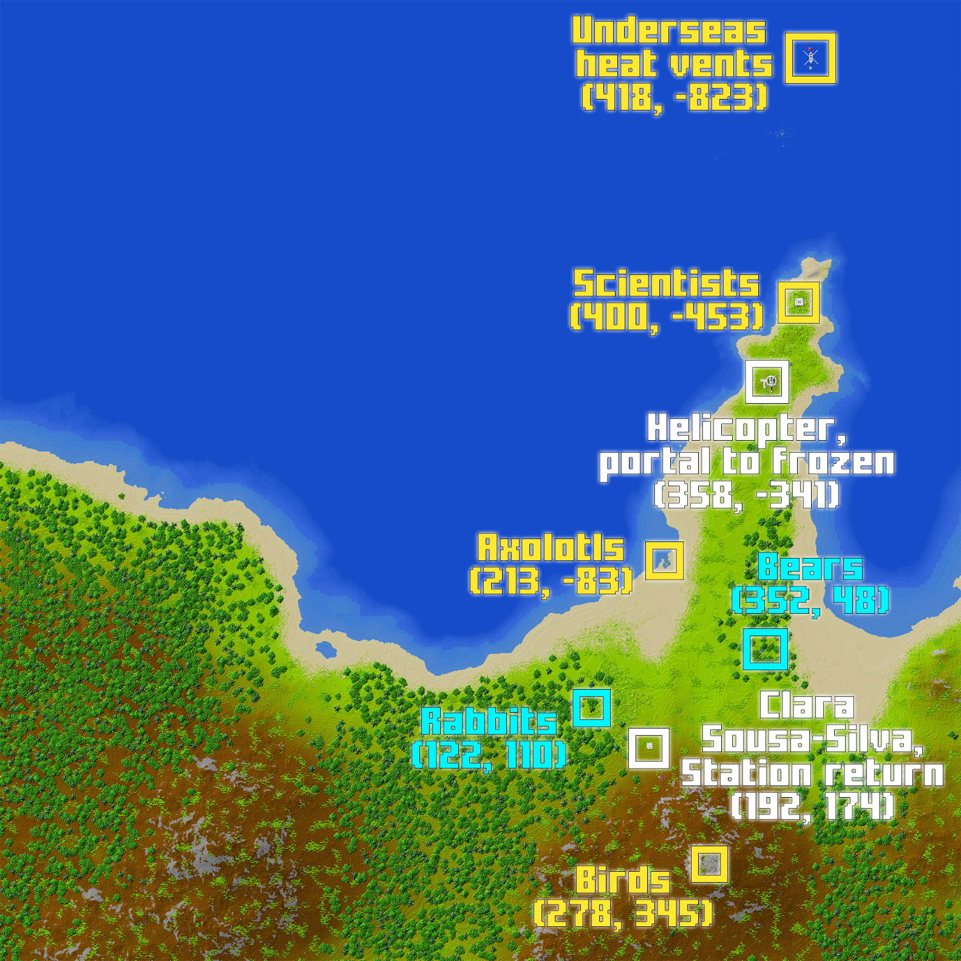
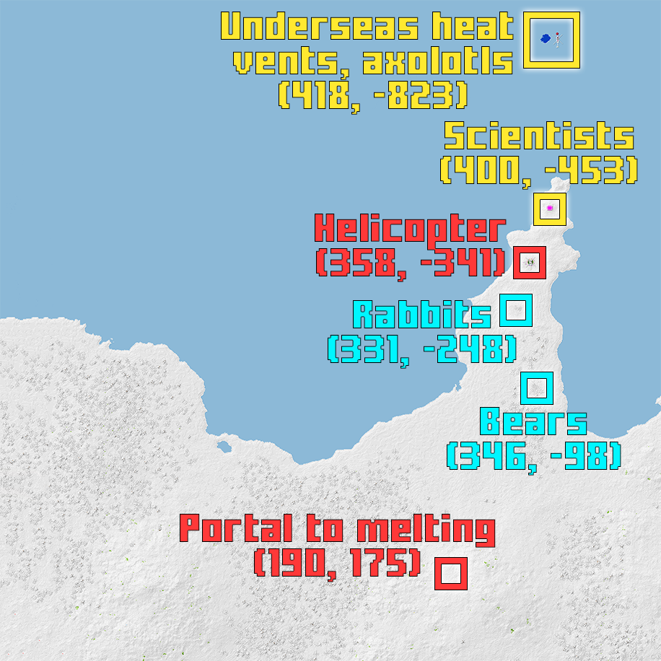
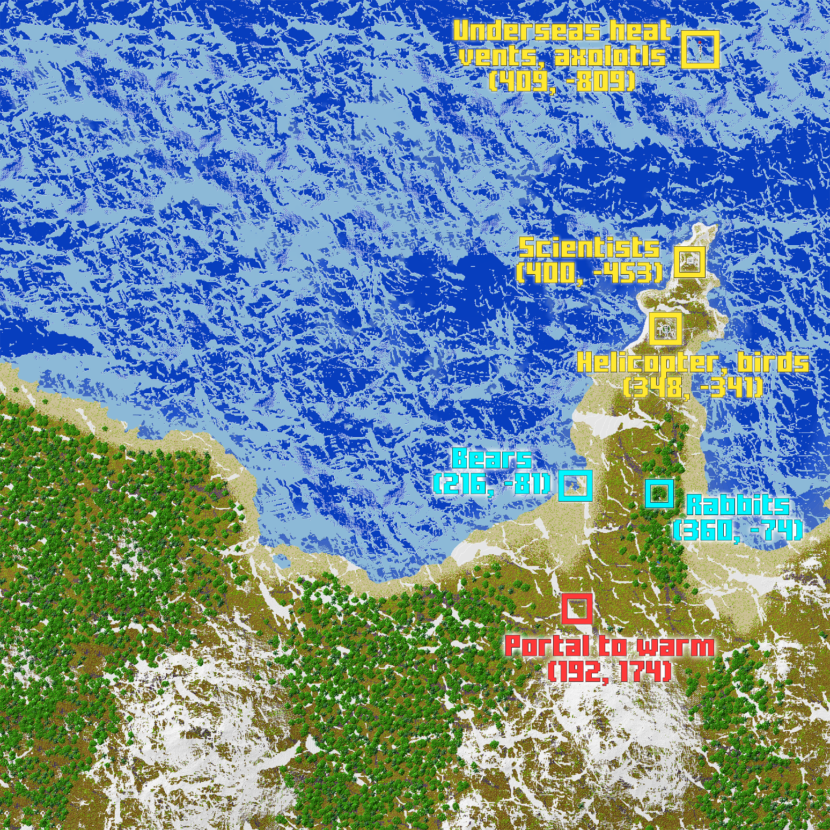

👩🏽‍🔬 NPC's and Their Roles
A non-player character (NPC) is a video game character that is controlled by the game's artificial intelligence (AI) rather than by a player. The NPC’s below are those that are tied to quests on the server or that offer relevant STEM information – there are others who may be present but not mentioned in this guide.
 | Located at  x: 192  y: 84  z: 174  ID: 154 | [Quantum Astrochemist] Clara Sousa-Silva – Issues the Time Traveler quest to help players explore the extreme seasonal changes on Tilted Earth. She is a part of the Explore [What-If] Earths questline.
 | Located at  x: 405  y: 73  z: -448  ID: 239 | Tower Mechanic – Talks about the function of the tower and what it does during periods of seasonal change, directs the player upstairs to the scientists.
 | Located at  x: 400  y: variable  z: -453  ID: 208 | Ornithologist – Describes what an Ornithologist is, encourages players to inference what happens to the birds during the winter. Location varies a little bit in the tower based on season.
 | Located at  x: -95  y: variable  z: -453  ID: 206 | Herpetologist – Encourages the player to inference about the amphibians in the Tilted Earth world. Location varies a little bit in the tower based on season.
 | Located at  x: 349  y: 85  z: -342  ID: 216 | Zoologist – Assigns the quest Measuring Migrations, a side-quest that challenges the players to find the birds and axolotls, the former which reside on the mountain in the summer and off-map in winter, and the latter are underwater when it’s winter.

